**S Abhishek AM.EN.U4CSE19147**

**Data Structures**

**1. Given a sorted (increasing order) array with unique integer elements, implement an algorithm to create a binary search tree with minimum height.**

class Node(object):  
 def __init__(self**,** x):  
 self.val = x  
 self.left = None  
 self.right = None  
  
def BST(arr):  
 if not arr:  
 return None  
 root = len(arr) // **2** node = Node(arr[root])  
 node.left = BST(arr[:root])  
 node.right = BST(arr[root + **1**:])  
 return node  
  
def display(node):  
 if not node:  
 return  
 print(node.val**,**end= " ")  
 display(node.left)  
 display(node.right)  
  
if __name__=='__main__':  
  
 arr=[]  
 n = int(input("Enter number of elements : "))  
 for i in range(**0,** n):  
 ele = int(input())  
 arr.append(ele)  
  
 r = BST(arr)  
 print("Pre Order Traversal :"**,**end=" ")  
 display(r)

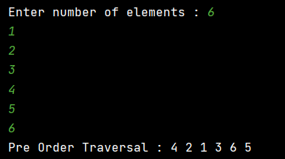

**2. Implement a function to check if a binary tree is a BST or not.**

class TreeNode(object):  
 def __init__(self**,** x):  
 self.data = x  
 self.left = None  
 self.right = None  
  
def check(root):  
 s = []  
 prev = None  
  
 while root or s:  
 while root:  
 s.append(root)  
 root = root.left  
 root = s.pop()  
 if prev and prev.data > root.data:  
 return False  
 prev = root  
 root = root.right  
 return True  
  
if __name__=='__main__':  
  
 head = TreeNode(**27**)  
 head.left = TreeNode(**14**)  
 head.right = TreeNode(**35**)  
 head.left.left = TreeNode(**10**)  
 head.left.right = TreeNode(**19**)  
 head.right.left = TreeNode(**31**)  
 head.right.right = TreeNode(**42**)  
  
 if check(head):  
 print("It's a BST!")  
 else:  
 print("It's not a BST!")  
  
 head = TreeNode(**10**)  
 head.left = TreeNode(**7**)  
 head.right = TreeNode(**15**)  
 head.left.left = TreeNode(**6**)  
 head.left.right = TreeNode(**9**)  
 head.right.left = TreeNode(**14**)  
 head.right.right = TreeNode(**14**)  
  
 if check(head):  
 print("It's a BST!")  
 else:  
 print("It's not a BST!")

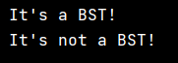

**3. Implement a function to find the in-order successor of a given node in a BST.**

**You may assume that each node has a link to its parent.**

class Node:  
 def __init__(self**,** data**,** left=None**,** right=None):  
 self.data = data  
 self.left = left  
 self.right = right  
  
  
def push(root**,** key):  
   
 if root is None:  
 return Node(key)  
  
 if key < root.data:  
 root.left = push(root.left**,** key)  
  
 else:  
 root.right = push(root.right**,** key)  
  
 return root  
  
  
def find_min(node):  
 while node.left:  
 node = node.left  
 return node  
  
  
def find(root**,** successor**,** key):  
 if root is None:  
 return None  
  
 if root.data == key:  
 if root.right:  
 return find_min(root.right)  
  
 elif key < root.data:  
  
 successor = root  
 return find(root.left**,** successor**,** key)  
  
 else:  
 return find(root.right**,** successor**,** key)  
  
 return successor  
  
  
if __name__ == '__main__':  
  
 arr = []  
 n = int(input("Enter number of elements : "))  
  
 for i in range(**0,** n):  
 ele = int(input())  
 arr.append(ele)  
  
 head = None  
 for i in arr:  
 head = push(head**,** i)  
  
 for i in arr:  
 if find(head**,**None**,** i):  
 print("The Successor of Node"**,** i**,** "is"**,** find(head**,**None**,** i).data)  
 else:  
 print("The Successor doesn't exist for Node"**,** i)

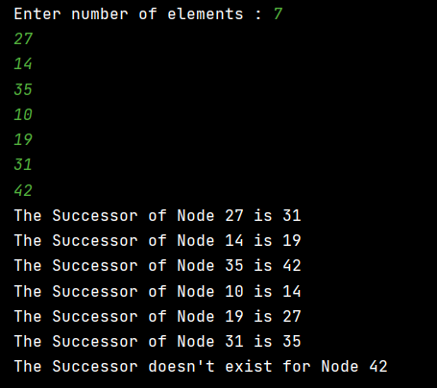

if __name__ == '__main__':  
  
 arr = []  
 n = int(input("Enter number of elements : "))  
  
 for i in range(**0,** n):  
 ele = int(input("Enter the Element {} : ".format(i+**1**)))  
 arr.append(ele)  
  
 e = int(input("Enter the Node : "))  
 head = None  
 for i in arr:  
 head = push(head**,** i)  
  
 for i in arr:  
 if find(head**,**None**,** i):  
 if i == e:  
 print("The Successor of Node"**,** i**,** "is"**,** find(head**,**None**,** i).data)  
 break  
 else:  
 print("The Successor doesn't exist for Node"**,** i)

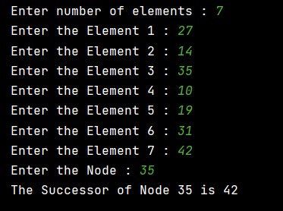

**4. Find the kth smallest element in a BST.**

class Node(object):  
 def __init__(self**,** x):  
 self.data = x  
 self.left = None  
 self.right = None

def kth_smallest(node**,** k):  
 stack = []  
 while node or stack:  
 while node:  
 stack.append(node)  
 node = node.left  
 node = stack.pop()  
 k -= **1** if k == **0**:  
 break  
 node = node.right  
 return node.data

def display(root):  
 if root:  
 display(root.left)  
 print(root.data**,**end= " ")  
 display(root.right)

if __name__ == '__main__':  
  
 head = Node(**10**)  
 head.left = Node(**7**)  
 head.right = Node(**15**)  
 head.left.left = Node(**6**)  
 head.left.right = Node(**9**)  
 head.right.left = Node(**14**)  
 head.right.right = Node(**14**)  
  
 print("\nInorder Traversal :"**,**end= " ")  
 display(head)  
 print()  
  
 n = int(input("\nEnter K to find the K'th Smallest : "))  
 print("\n\t\t - {} Smallest Element is {}".format(n**,**kth_smallest(head**,** n)))  
 n = int(input("\nEnter K to find the K'th Smallest : "))  
 print("\n\t\t - {} Smallest Element is {}".format(n**,** kth_smallest(head**,** n)))  
   
 head = Node(**27**)  
 head.left = Node(**14**)  
 head.right = Node(**35**)  
 head.left.left = Node(**10**)  
 head.left.right = Node(**19**)  
 head.right.left = Node(**31**)  
 head.right.right = Node(**42**)  
   
 print("\nInorder Traversal :"**,**end= " ")  
 display(head)  
 print()  
 n = int(input("\nEnter K to find the K'th Smallest : "))  
 print("\n\t\t - {} Smallest Element is {}".format(n**,**kth_smallest(head**,** n)))  
 n = int(input("\nEnter K to find the K'th Smallest : "))  
 print("\n\t\t - {} Smallest Element is {}".format(n**,** kth_smallest(head**,** n)))

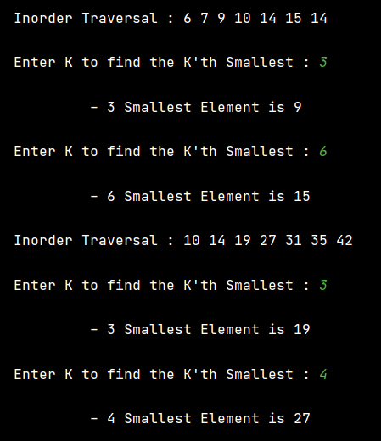

**One Drive :** [**Click Me!!**](https://amritauniv-my.sharepoint.com/:f:/g/personal/sabhishek_am_students_amrita_edu/EtcdQ2a8gXdAqWjEu-vrim0BEEdI2dLq9VWVID29QkthIQ?e=gcvzwp)

**Thankyou!!**